Table of Contents

Pre-requisites 2

Installation guide 2

Seed the database. 3

Build the back-end solution 4

Configuring the Application 5

Changing the ConnectionString 6

Changing the PageSize 6

Changing the search suggestion count 6

*Task 1 Back-end – Create a Web Service 7

WebApi documentation via swagger 7

*Task 2 Front-end– Paging 7

Angular site 7

Mobile View 7

*Task 3 Front-end – Header Sorting 8

Solution Architecture Overview 9

Hosts 9

EcomEngineTechChallenge.ApiHost 9

EcomEngineTechChallenge.ConsoleSeeder 9

EcomEngineTechChallenge.Spa 10

Data 10

EcomEngineTechChallenge.Data 10

Business 11

EcomEngineTechChallenge.Business.Common 11

Infrastructure 11

EcomEngineTechChallenge.Contracts 11

Tests 12

EcomEngineTechChallenge.Tests.Integration 12

EcomEngineTechChallenge.Tests.Unit 12

# Pre-requisites

* Visual Studio 2017
* .Net core 2.0
* NodeJS (https://nodejs.org/en/download/current/)

# Installation guide

1. Download the source codes

<https://drive.google.com/open?id=1UXrMhEhob4JSZFT2ZcKOoZvzFtYZWi5o>

1. Extract EcomEngineTechChallenge.zipx

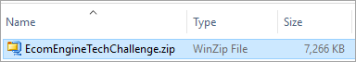

1. Open the solution

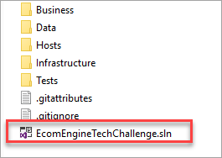

## Seed the database.

Run the EcomEngineTechChallenge.ConsoleSeeder project.

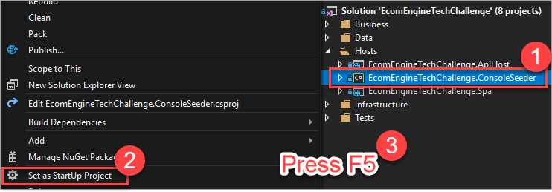

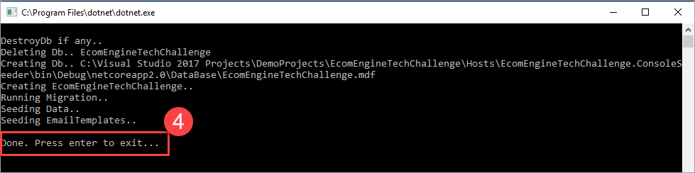

## Build the back-end solution

1. Set start-up Projects

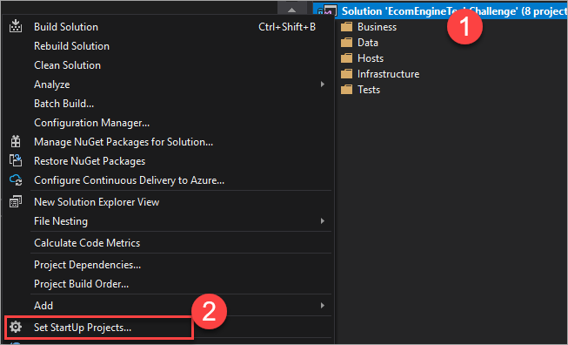

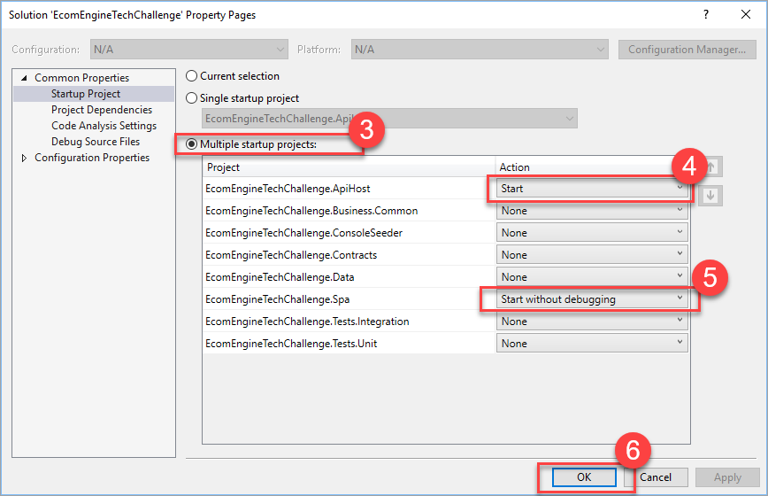

1. Build the solution

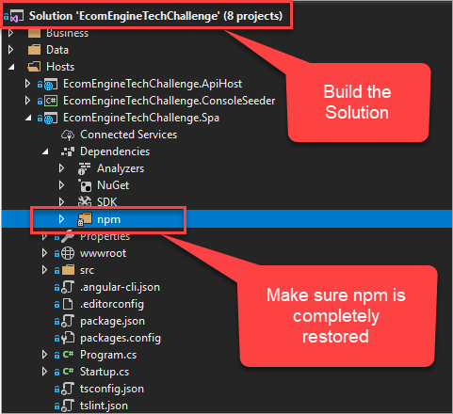

1. Run the solution by pressing F5

# Configuring the Application

Open *appsettings.json*

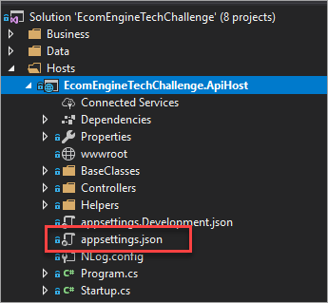

## Changing the ConnectionString

Modify the entry to change the database name, etc..

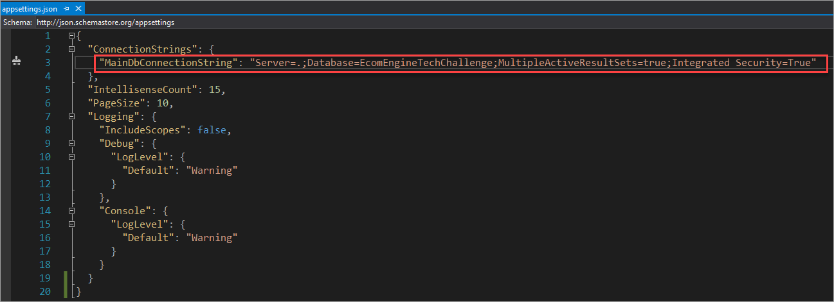

## Changing the PageSize

Increase or decrease values here. Default is 10 rows.

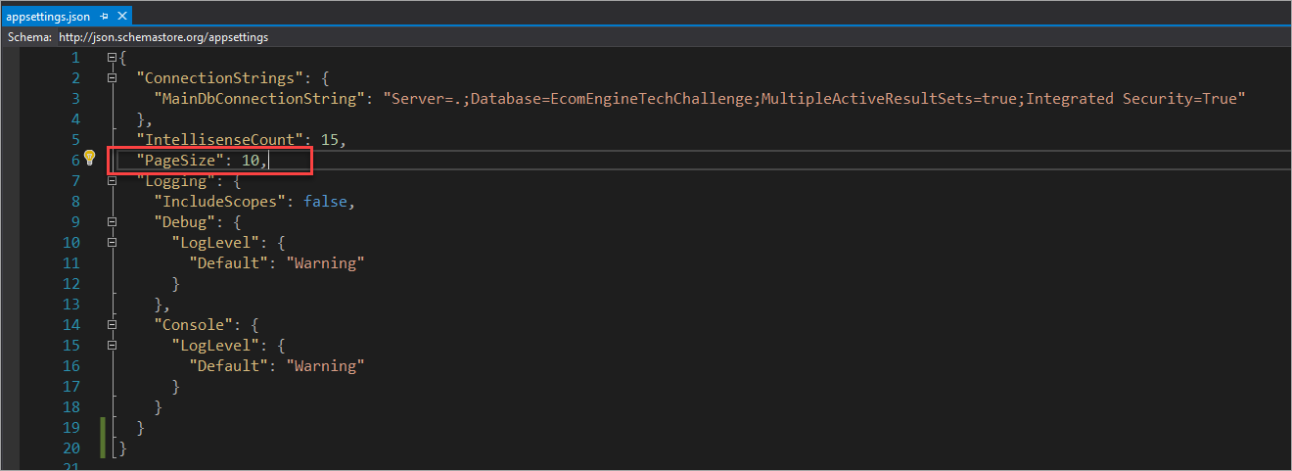

## Changing the search suggestion count

Increase or decrease values here. Default is 15 suggestions..

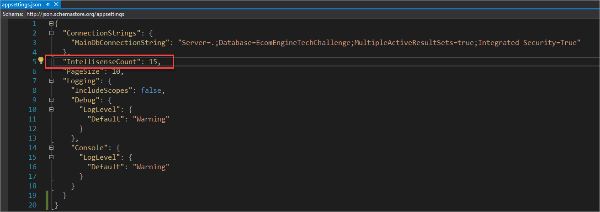

# *Task 1 Back-end – Create a Web Service

## WebApi documentation via swagger

An optional component that will allow you to play around with the eComEngine endpoints.

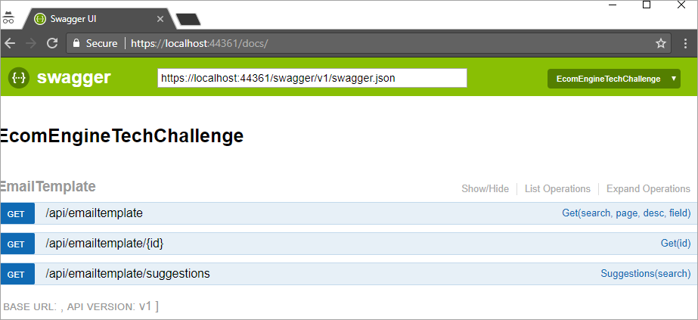

# *Task 2 Front-end– Paging

## Angular site

Click on the page indicators to navigate from one page to another.

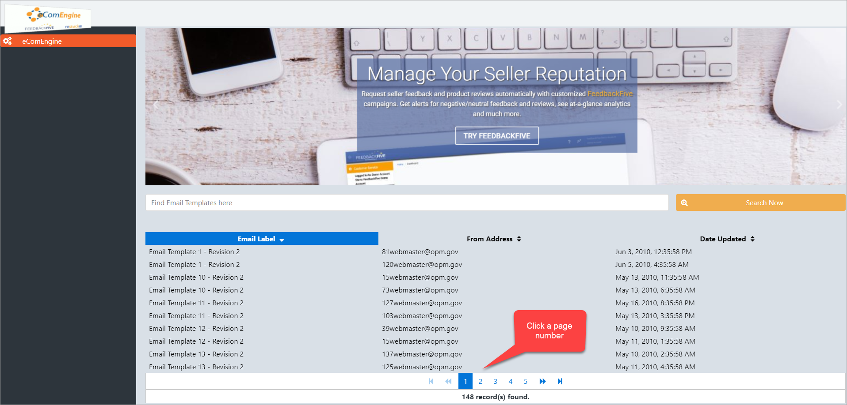

## Mobile View

This sample page is designed for mobile browsing as well.

# *Task 3 Front-end – Header Sorting

Click on the headers to toggle sorting between ascending and descending.

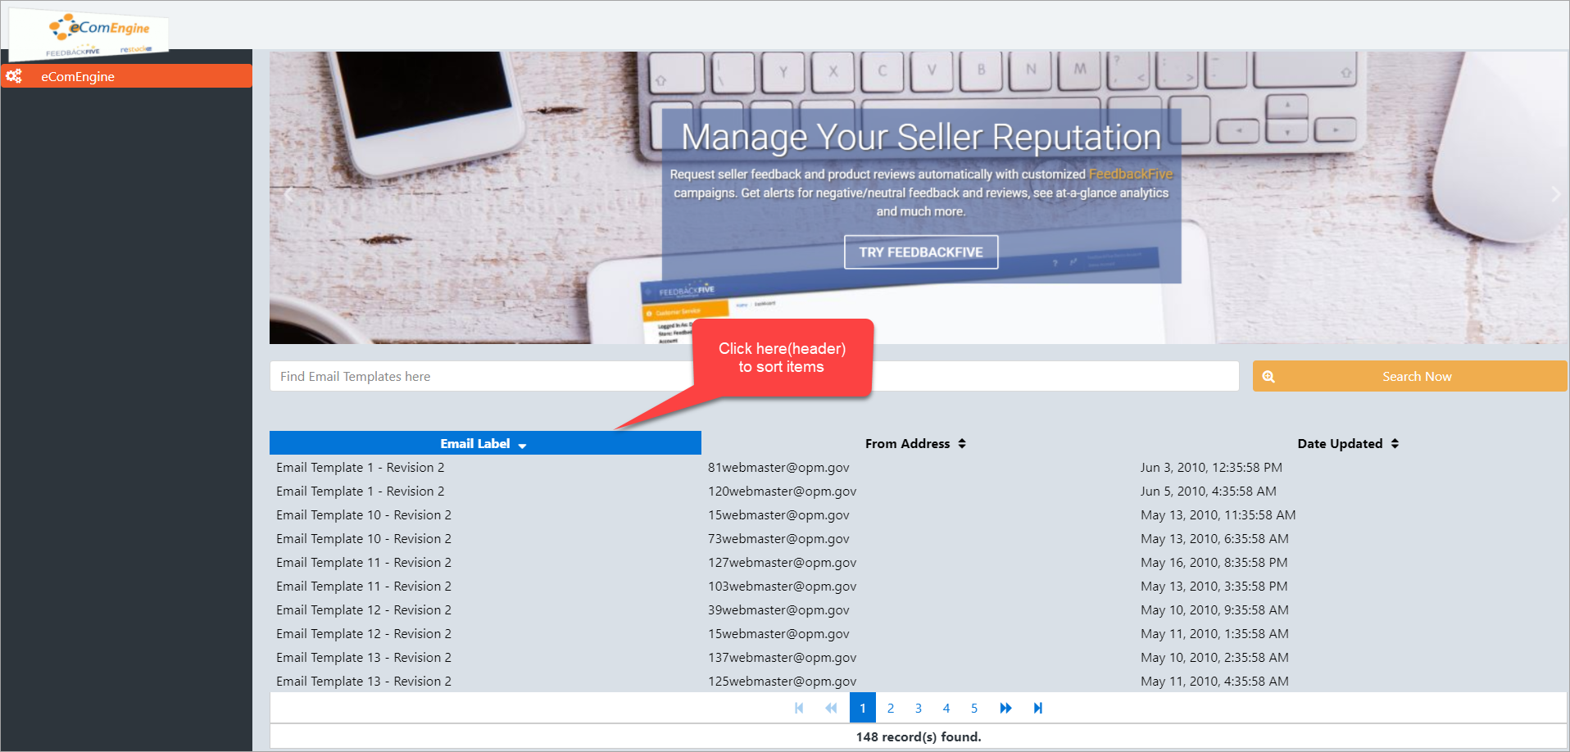

# Solution Architecture Overview

In bird’s eye view, the solution is separated into 5 different areas namely: **Business,** **Data**, **Hosts, Infrastructure** and **Tests.** This solution contains a little bit of everything of SOA.

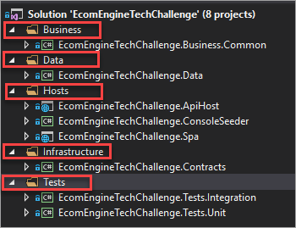

## Hosts

### EcomEngineTechChallenge.ApiHost

* This is the main project. It hosts the WebApi.
* Uses Dependency Injection via MEF.

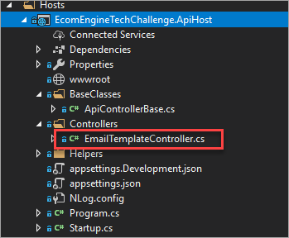

### EcomEngineTechChallenge.ConsoleSeeder

* Used to create the database and populate it with sample data.

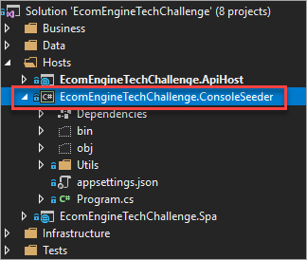

### EcomEngineTechChallenge.Spa

Contains the Angular5 app.

* wwwroot – contains precompiled javascripts from my machine – ready to use.
* ecomengine – this is where the front-end codes are located.

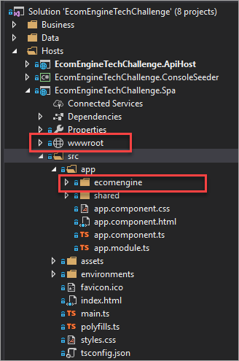

## Data

Uses EntityFramework Core 2.0

### EcomEngineTechChallenge.Data

* This is where the EF Datacontext is found.
* DataRepositoryGuid.cs is a general purpose class for retrieving data – highly testable.

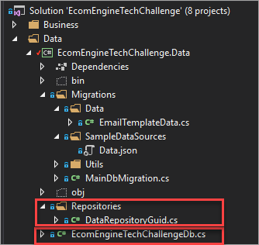

## Business

### EcomEngineTechChallenge.Business.Common

* EmailtemplateSearchResponse.cs - contains other properties needed by the Angular 5 client.
* EmailTemplate.cs – the entity representing the sample data.

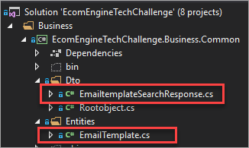

## Infrastructure

### EcomEngineTechChallenge.Contracts

* A separate place for enums, contracts, configuration, etc..

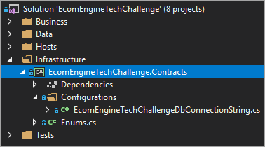

## Tests

Uses xUnit, Nsubstitute and Shouldly.

### EcomEngineTechChallenge.Tests.Integration

* Contains automated integration tests.

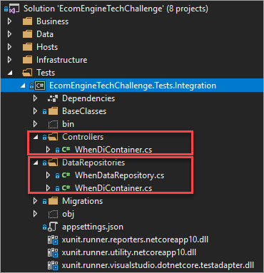

### EcomEngineTechChallenge.Tests.Unit

* Contains automated unit tests.

